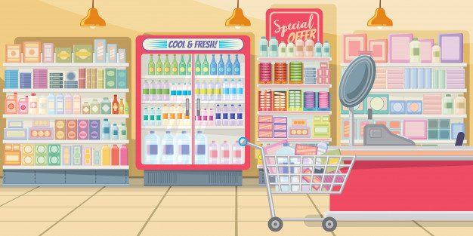

**Analysis of Supermarket Data Across the Country – Company XYZ**

Raimi Azeez Babatunde

Ustacky Pandas Project

### INTRODUCTION

**Company XYZ** owns a supermarket chain across the country. Each major branch located in 3 cities across the country recorded sales information for 3 months, to help the company understand sales trends and determine its growth, as the rise of supermarkets competition is seen to increase.

This project is aimed at employing data science & analytics skills to collect data, explore the data, perform analysis, create visualizations, and generate insights on the data to determine how best to keep the supermarket thriving and above other competitors.

This analysis shows to mention a few:

* There’s no direct relationship between unit price and quantity sold.
* Member customers bring more sales than normal/regular customers.
* Lagos has the highest record sales but not the highest gross income i.e. high sales record does not translate to a high gross income.
* Epay is the most used payment method.

### DATA OVERVIEW & METHOD

Data collected from all three stores used for this project analysis includes:

**Invoice ID:** Customer Identification number

**Branch:** Supermarket Branch across the country (A, B, C)

A - Lagos Branch

B - Abuja Branch

C - Port Harcourt Branch

**City**: Supermarket Location

**Customer Type:** Type of customers, Members - Returning customer with membership card, Normal - Customer without membership (could be returning, first-time or walk-in customer)

**Gender**: Customer Gender Information

**Product line:** Product categorization groups - Electronic accessories, Fashion accessories, Food and beverages, Health and beauty, Home and lifestyle, Sports and travel

**Unit Price**: Price of each product in Naira

**Quantity**: Number of products purchased by customer

**Tax**: 5% tax fee for customer buying

**Total**: Total price including tax

**Date**: Date of purchase (Supermarket Record available from January 2019 to March 2019)

**Time**: Purchase time (Supermarket Hours - 10am to 9pm)

**Payment**: Payment used by customer for purchase (3 methods are available – Cash, Card and Epay)

**COGS**: Cost of goods sold

**Gross margin percentage**: Gross margin percentage

**Gross income:** Gross income

**Rating**: Customer Satisfaction rating on their overall shopping experience (On a scale of 1 to 10)

### ANALYSIS & RESULTS

1. Fig 1-2 – Shows the Branch and City and their Sales Records. This shows that Lagos (Branch A) a (Branch B) have the highest sales records respectively. 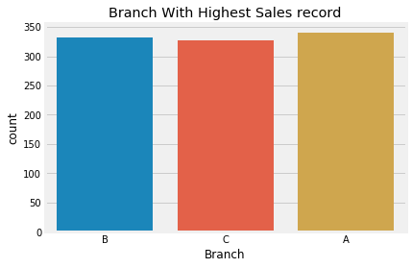

### 

Fig. 2 – Sales Record Per City.

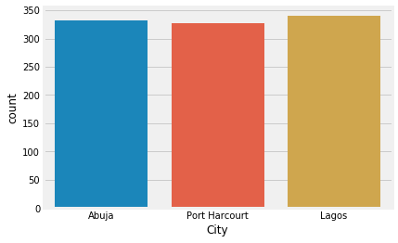

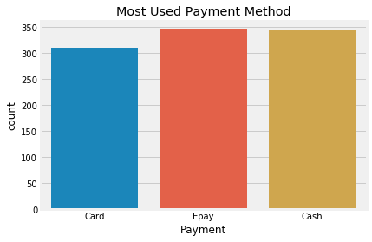Fig.3 – Shows the most used payment method is Epay, followed closely by Cash and then Card.

Fig.4 – Shows the sales record per product line. Fashion accessories are the highest selling product line followed by Food & Beverages.

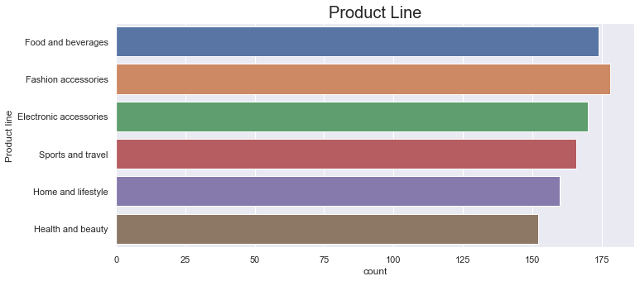

Fig.5 – Shows the sales record per product line by payment method. This shows that people who by Electronic accessories pay more by cash than any other group. People who buy Fashion, Home & Lifestyle & Health & Beauty Accessories pay more using Epay. Those who buy Food & Beverages pay more using card method.

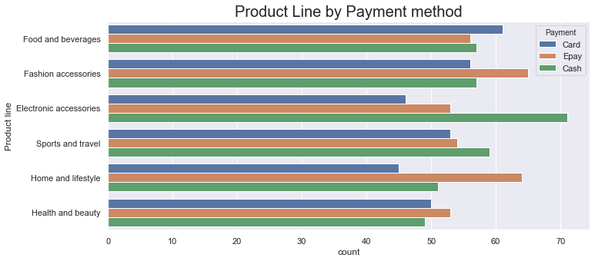

Fig.6 – Shows the Sales record per product line by branch. This Shows that the Lagos branch sold more Home & Lifestyle products compared to any other branch. Abuja branch sold more sport & Travel products compared to other branches and PortHacourt branch sold more Food & Beverages compared to other branches.

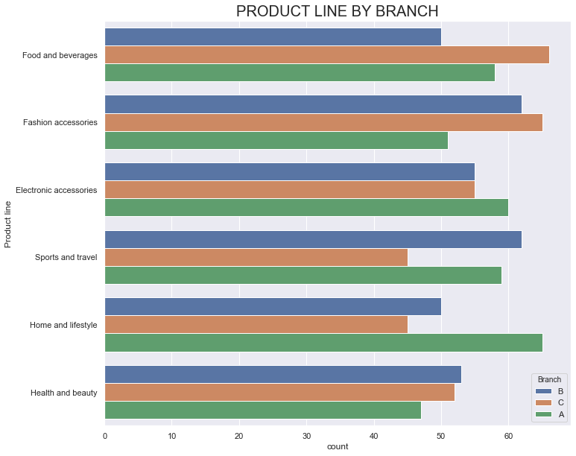

Fig.7 – Shows the Ratings of each branch. This shows Lagos and Abuja branch have an equal rating above 7 and Abuja branch have a lower rating below 7.

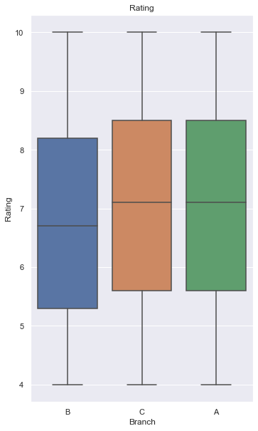

Fig.8-9 – Shows the product line by payment methods based on customer gender. This shows the stores have a higher number of female customers for all product line except Health & Beauty

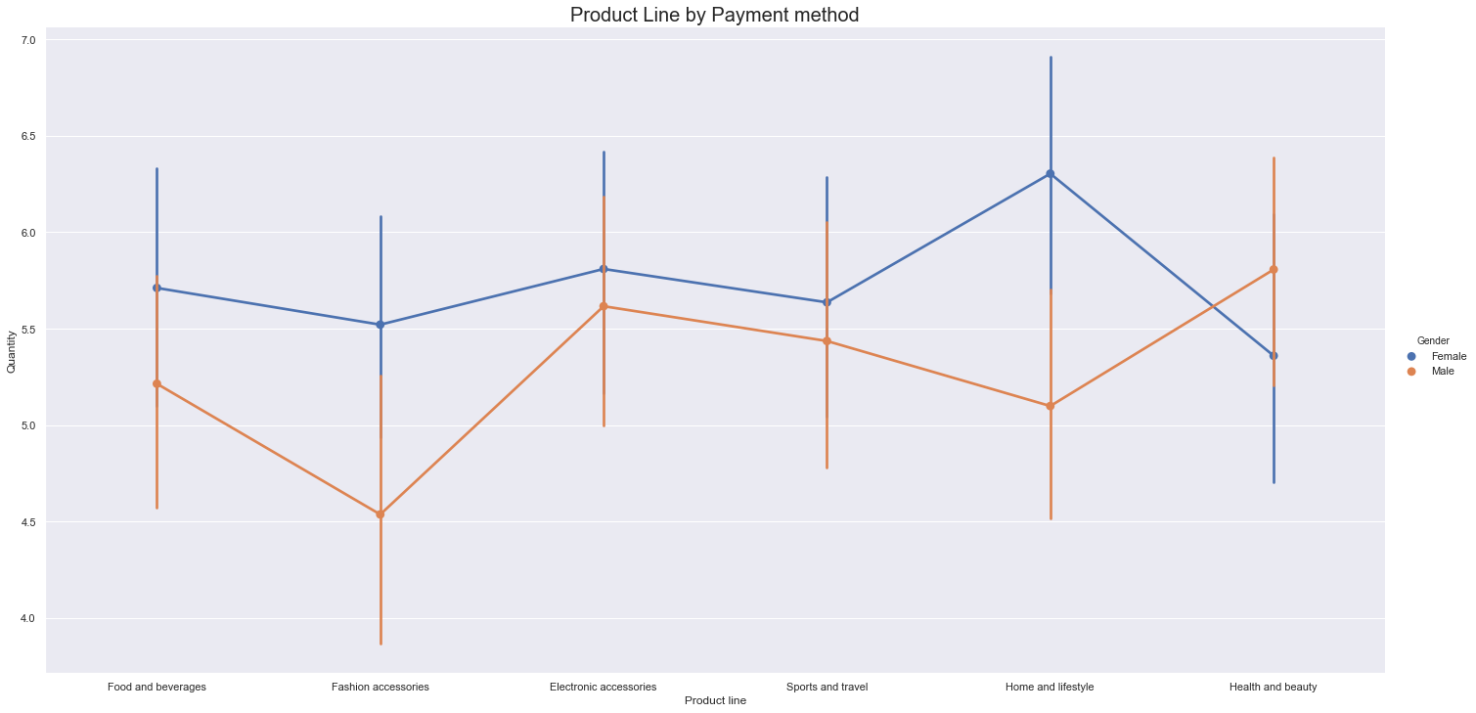

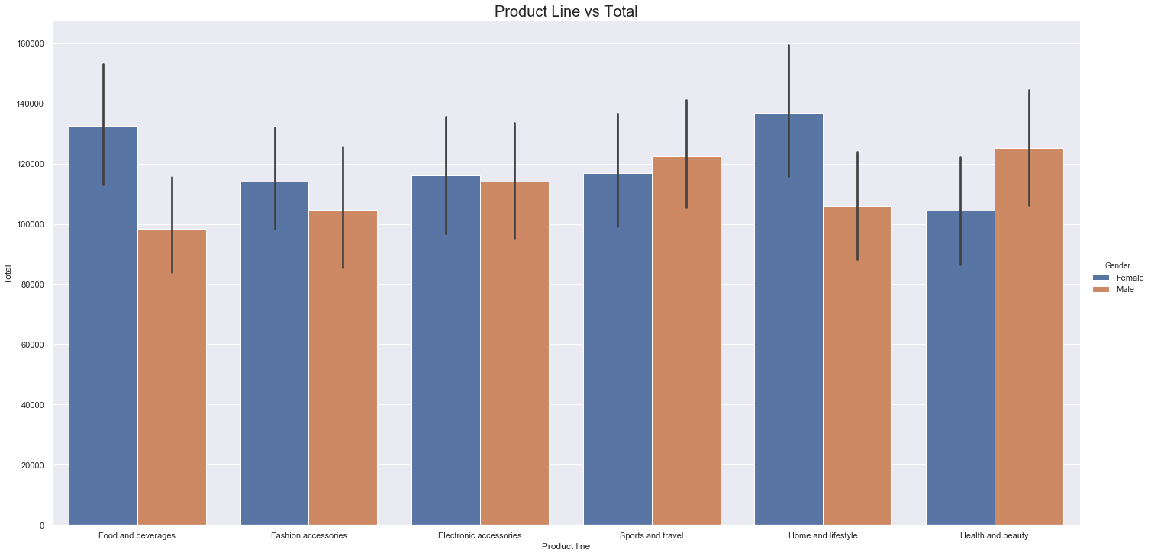

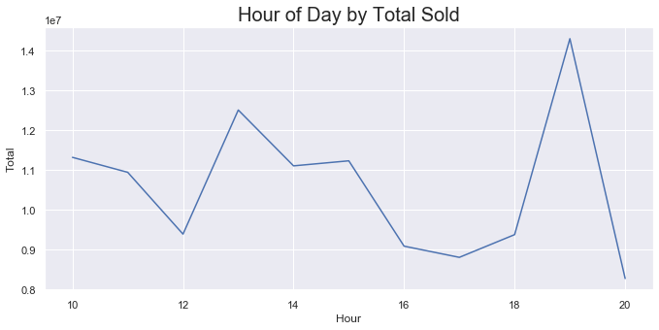Fig.10 – Quantity Sold per unit price. This shows no solid direct relationship between the quantity of items sold based on their unit price as product with a low unit price have low quantity sold. This implies that the quantity of items sold depends on other factors such as need rather than the unit price.

Fig.11 – This should the Total Sold items by the hour of the day. This shows that on the average more goods are sold between 18:00 & 20:00 hour of the day followed by between 12:00 & 14:00 hour.

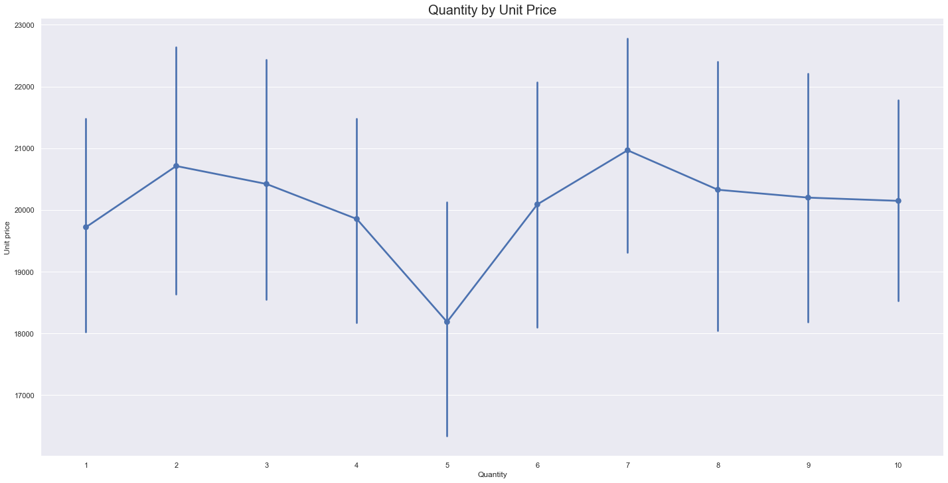

Fig.12 – Shows Total sales by month. This shows that more goods were sold in the 1st and 3rd Month compared respectively.

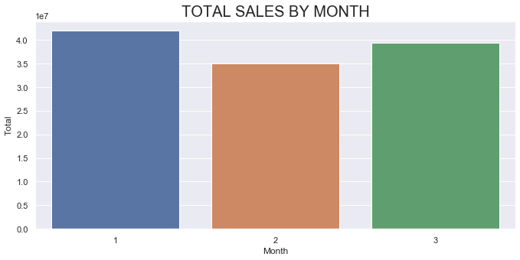

Fig. 13 – Shows gross income for each month by product line. This shows that the stores sold more Food & Beverages, Electronics and Home & Lifestyle products in the first month. the stores sold and all time high record of sports & travel products.

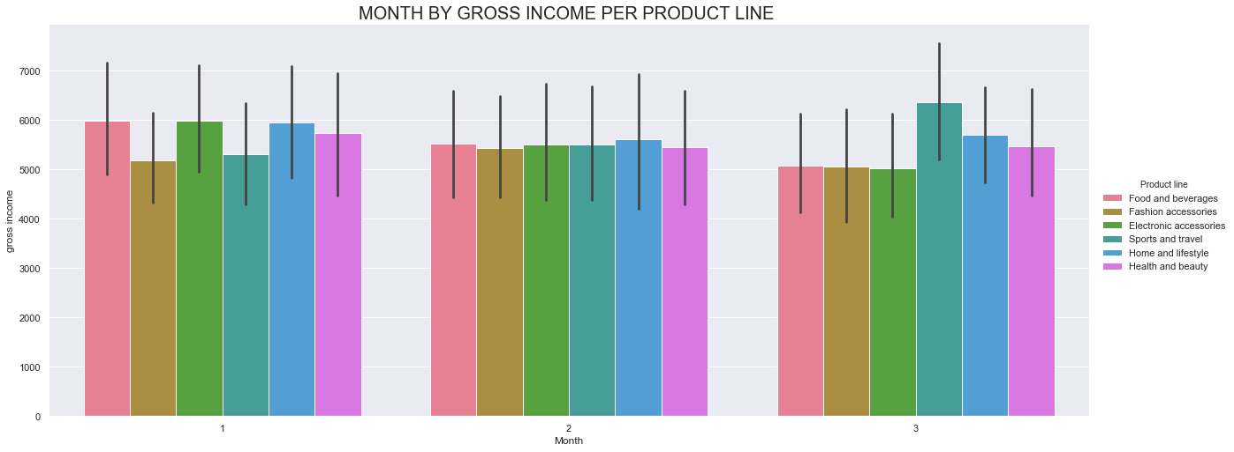

Fig. 14 – Shows the Gross income per product line. This shows that the highest gross income was brought in by Home & Lifestyle and Sports & Travel product line respectively.

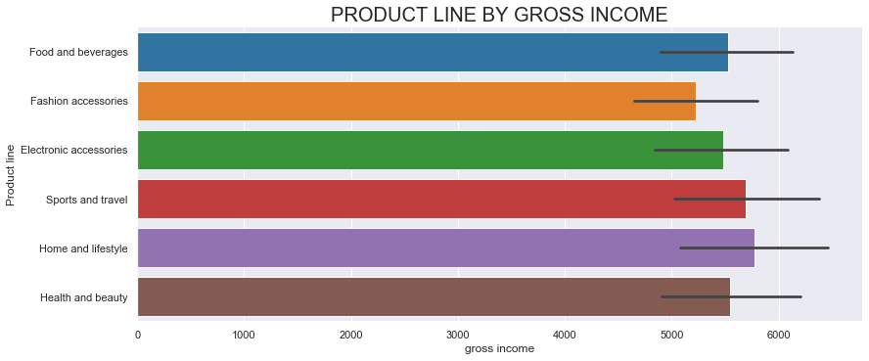

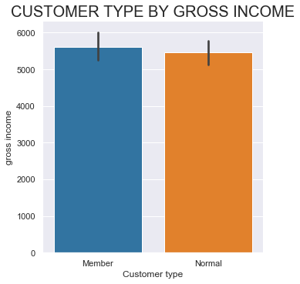Fig. 15 - Shows the gross income by Customer type. As a measure of loyalty, customers who have membership card in the stores bring in more gross income than regular customers

Fig. 16 – Shows the Quantity sold by Product line per member type. This shows that members buy more food & beverages and health & beauty products compared to other products and regular customers buy more sports & Travel products.

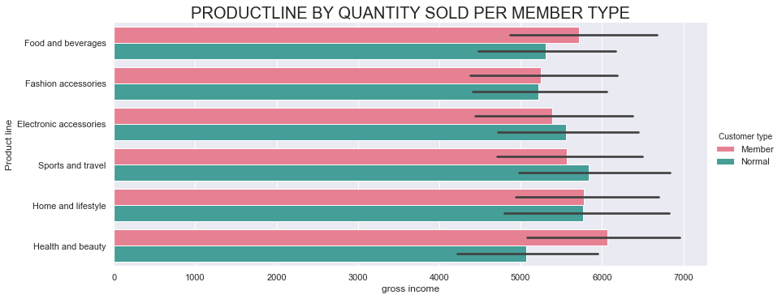

### conclussion

The purpose of the project is to analyze the supermarket data, provide insights to determine sales trends and growth. The analysis shows:

1. The supermarket records more sales in Lagos than other branches but recorded the highest gross income in PortHarcourt. This implies that a high sales record does not automatically translate to high gross income.
2. The highest payment method used is Epay and the least used is Card payment. The economy is going cashless; hence the company should make available more easy ways to ease payment methods by card for customers and improve on the epay method.
3. This Shows that the Lagos branch sold more Home & Lifestyle products compared to any other branch. Abuja branch sold more sport & Travel products compared to other branches and PortHacourt branch sold more Food & Beverages compared to other branches. The company should consider stocking more varieties of products that a sold best in each branch.
4. The company should improve on the overall service provision in the Abuja branch as it has a low rating.
5. The unit price of product does not translate to increase sale, hence the company should not stock goods excessively because of the low unit price.
6. More sales are made with the hours of 12:00 – 2:00 and 18:00 – 20:00 hours, company should therefore ensure proper staffing and service provision between these periods to increase costumer rating and sales too.
7. Customers who are members are loyal and bring in more sales to the company. The company can consider more loyalty programs such as discount vouchers for member, raffle draws etc. for members to attract more customers to become a member and drive more sales.

### FUTURE WORK SUGGESTION

I strongly suggest the company collects more data on Collect data on products within each product line to find combination of products which complement each other or products which customers buy to when they buy certain products. This can be used to create discount packages and also guide in stocking the appropriate products.

Also, the company should make correction on the mode and method of data recording in the future as there’s an error between the Tax, Gross Income and Cost of Goods Sold in the dataset. This ensures more certainty in the analysis.